Year 9 Biology Homework #1 Name:_________________________________
Due______________________________
HUMAN NERVOUS SYSTEM
Nervous system: a __________________________ system that controls all parts of your __________.
The two main parts of the human nervous system:
◆ ____________________ nervous system (CNS).
- Made up of the ______________ and the spinal cord.
- Receives information from all over the body, ________________________ the information and sends out messages telling the body how to _________________.
◆ Peripheral ________________ system (PNS).
- Made up of the ______________ that carry messages to and from the CNS and other parts of the body.
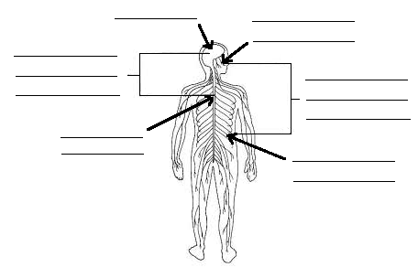
Label the diagram below using figure 7.1.1 on page 225.
Term | Definition/description
Central  Nervous  System | _____________________________________________________________________________  ____________________________________________________________________________
Peripheral  Nervous  System | _____________________________________________________________________________  ___________________________________________________________________________
Nerve cells
The nervous system is made up of trillions of ___________ cells (neurons).
Neurones: nerve _____________.
Neurones carry electrical ____________________ (nerve impulses) from one part of your body to another very quickly. The nerve impulses can only travel in one ___________________.
Nerve impulses: the electrical messages carried by a ______________ cell.
A neurone has four main parts.
List them below.
________________________________________________________________________________________
Cell body: the part of the neurone that contains the ___________________.
Dendrites: branches from the cell body that receive _________________ from other neurons.
Axon: a nerve fibre that sends nerve _________________ away from the cell body.
There are two common types of neurones.
Motor neurones and ____________________ neurones.

Motor neurones: nerve cells that carry messages from the __________to effectors.
Effectors: muscles or glands that put messages into ___________________.
Myelin sheath: the insulating layer that covers a _________________.

Motor neurone diagram
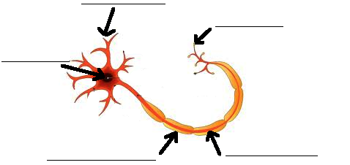

Sensory neurones are:

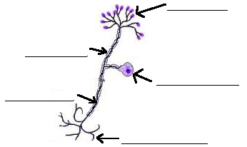
Sensory neurone diagram

1. Explain the difference between the cell body in the motor neurone compared to the cell body in the sensory neurone.
________________________________________________________________________________________
________________________________________________________________________________________
________________________________________________________________________________________
2. What is the insulating covering around the axon called? _________________________________________
Why is it needed?
3. What is located inside the cell body? ________________________________________________________
Neurotransmitter: a ___________________________ that sends signals from one neurone to another.
Synapse: the space between two __________________.
Label the following diagram illustrating a synapse between two neurones.
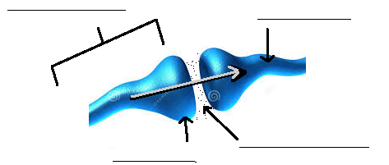

Year 9 Biology Homework #2 Name:_________________________________
Due______________________________

Term | Definition/description | Diagram/example
Neurones | _________________________________________
Nerve  impulses | _____________________________________________________________________________  ____________________________________________________________________________
Cell body | _________________________________________  _________________________________________  _________________________________________
Dendrites | _________________________________________  _________________________________________
Axon | _________________________________________  _________________________________________  _________________________________________
Motor  neurone | _________________________________________  _________________________________________  _________________________________________
Effectors | ____________________________________________________________________________  _____________________________________________________________________________
Myelin  sheath | _____________________________________________________________________________  ____________________________________________________________________________
Term | Definition/description | Diagram/example
Sensory  neurones | _________________________________________  ________________________________________  ________________________________________  ________________________________________
Neuro-  transmitter | _____________________________________________________________________________  ____________________________________________________________________________
Synapse | _________________________________________  _________________________________________  _________________________________________

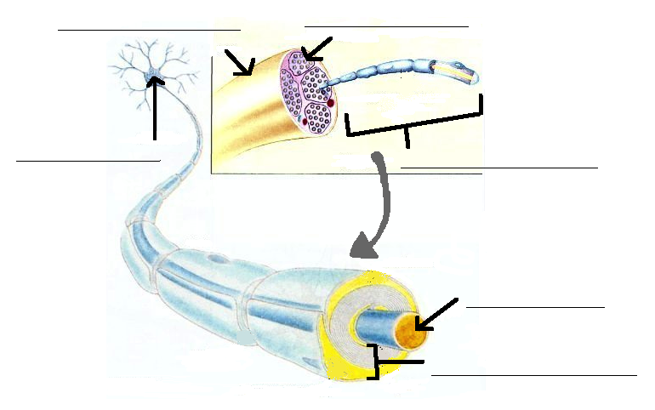
Diagram showing nerve
The brain
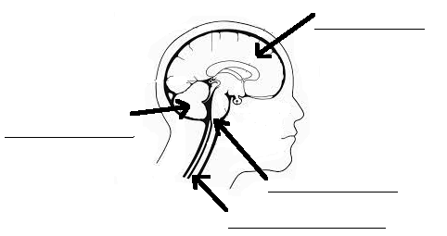
Cerebrum: part of the brain that controls conscious thoughts, controls the movement and receives sensory messages from each body part.

The left hemisphere controls the __________________ side of the body.
The right hemisphere controls the ___________________ side of the body.
Cerebellum: part of the brain responsible for coordination and balance.
Brain stem: part of the brain where the spinal cord enters the skull.
Medulla: the lower half of the brain _____________.
Term | Definition/description
Cerebellum | _____________________________________________________________________________  ____________________________________________________________________________
Brain stem | _____________________________________________________________________________  ____________________________________________________________________________
Medulla | _____________________________________________________________________________  ____________________________________________________________________________

Year 9 Biology Homework #3 Name:_________________________________
Due______________________________
PERIPHERAL NERVOUS SYSTEM
There are two parts of the peripheral (PNS).
The somatic nervous system.
The _________________________ nervous system.
Somatic nervous system
Somatic nervous system: part of the nervous system that coordinates the movement of the body and receives information from the sensory _____________________.
Receptors: special cells that detect ___________________________.
Stimulus: any factor that stimulates a receptor and causes a __________________________.
Optic nerve: the nerve that carries messages from the ___________ to the brain.

1. Explain how the skin on your body protects itself from the outside world.
________________________________________________________________________________________
________________________________________________________________________________________
2. Explain how the receptors in your ear helps you to keep your balance.
________________________________________________________________________________________
________________________________________________________________________________________
________________________________________________________________________________________
3. Explain what chemoreceptors are and where they are located.
________________________________________________________________________________________
________________________________________________________________________________________
________________________________________________________________________________________

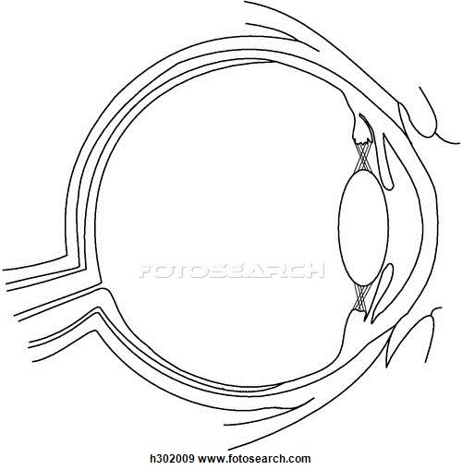
What are photoreceptors?
Locate and label the part of the eye where photoreceptors are located
There are two types in the human eye. Name each and describe their function.
Term | Definition/description | Diagram/example
Somatic  Nervous  System | _____________________________________________________________________________  ____________________________________________________________________________
Receptors | _________________________________________
Stimulus | _________________________________________  _________________________________________

Autonomic nervous system
Autonomic nervous system: the system controlling _________________________________ actions.
Sympathetic nervous system: part of the nervous system that speeds up the functions of the body and makes the body work more ______________________________.

List seven functions that the sympathetic nervous system has. (Page 230 text book).
________________________________________________________________________________________
________________________________________________________________________________________
________________________________________________________________________________________
________________________________________________________________________________________
________________________________________________________________________________________
________________________________________________________________________________________
________________________________________________________________________________________
________________________________________________________________________________________
________________________________________________________________________________________
________________________________________________________________________________________
________________________________________________________________________________________
________________________________________________________________________________________
________________________________________________________________________________________
________________________________________________________________________________________
________________________________________________________________________________________
Parasympathetic nervous system: part of the nervous system that _________________ the body down and controls it when it is resting.
List five functions that the parasympathetic nervous system has. (Page 231 text book).
________________________________________________________________________________________
________________________________________________________________________________________
________________________________________________________________________________________
________________________________________________________________________________________
________________________________________________________________________________________

1. Compare the main difference between the sympathetic nervous system and the parasympathetic nervous system.

Term | Definition/description | Diagram/example
Autonomic  Nervous  System | _____________________________________________________________________________  ____________________________________________________________________________
Sympathetic  Nervous  System | _________________________________________  _________________________________________  _________________________________________  _________________________________________
Para-  sympathetic  Nervous  System | _________________________________________  _________________________________________  _________________________________________  _________________________________________

Responding to stimuli
A stimulus response model is a simple model of your _____________ system.
_____________________ stimulate the sensory nerves and these nerves send a message to the brain.
The brain works out the ____________________ that is required then sends a message along motor nerves to the effectors (these are the muscles or glands that will put the response into effect).
Look at figure 7.1.15 as an example of a stimulus response model.

If you touch something __________ or sharp, you automatically pull your hand away.
Reflex action protects your body from danger.

